Ascent III
Complete the final step in the Bear Hunter System with Skin. In this stage, you'll learn how to hyper-optimise your chunk structure to address any lingering limitations to your retention or depth.
Overview and recommendations
Key dimensions | Deep processing, self-regulation
Recommended pace | Most learners see best results with 6 hours of theory over 3 to 4 weeks.
Recommended practice | Most learners see best results with 3 to 6 weeks of practice, with most of the theory covered in the first 3 to 4 weeks.
Progression tips | The difficulty of technique accuracy in this stage depends on the competence in Ascent 2. Pay careful attention to the checkpoint and ensure that you continue practising until you have comfortably met the checkpoint criteria before moving to the next stage.
How this stage helps you
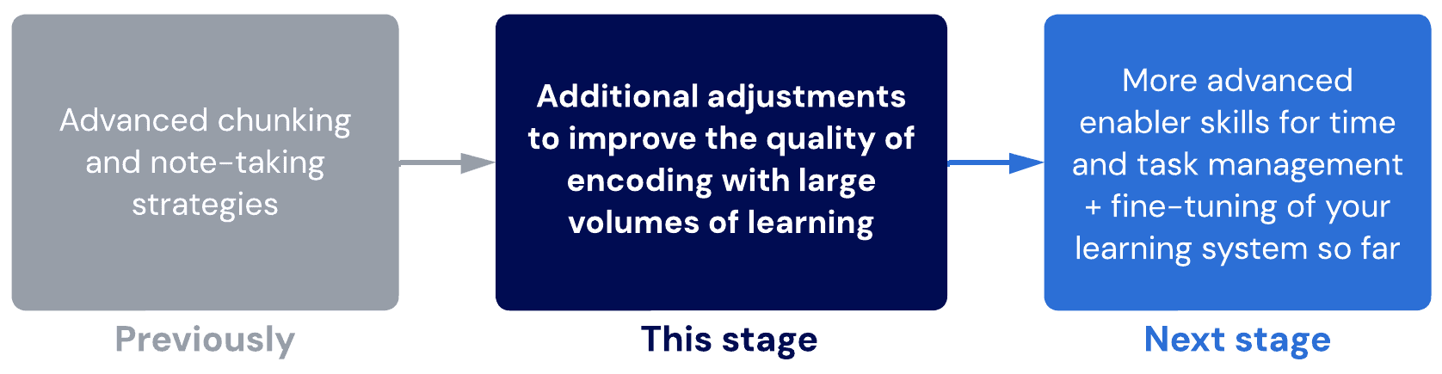

Lessons
- Bear Hunter System: Skin
Overview of the Skin step; the final step in the Bear Hunter System.
- Chunking
We recap the essentials of chunking and enforce the 2-4 Rule.
- GRINDE maps
Learn about GRINDE maps, an extension of VPReFRE specific to chunk-mapping.
Sub-lessons
- GRINDE map examples
- Skin examples
As before, we demonstrate the Skin step in various subjects and topics.
Sub-lessons
- Biology 1
- Biology 2
- Chemistry
- English – text response
- English – unfamiliar text
- Languages
- Maths
- Intuitive chunking
Mastering intuitive chunking is one of the most advanced levels of chunking. Let's learn about it!
- Final checkpoint – Ascent 3
You know the drill!

- Bear hunter system – skin
Skin is a step for exclusively refining your higher-order learning at the evaluate level.
As you have probably noticed by now, your chunk structure changes to reflect your most up-to-date understanding of how concepts are related to each other. It can take multiple Aim-Shoot cycles to get to a point where we now have a comprehensive view of all the relationships.
With the Skin step, we consolidate, integrate, refine, and make judgments on how we want our final chunk structure to look. After all this time, it's finally time to create some more certainty!
Further reading
Ultralearning – book and YouTube video (note that the concepts discussed in Ultralearning are incorporated and further refined in the BHS)
In this stage:
The following techniques are new.
Technique | Rationale
Bear Hunter System – Skin (GRINDEmaps) | A more advanced form of mind mapping that greatly facilitates high-level chunking and relationship-priority learning.
The following are techniques from prior stages that you should continue using.
Technique | Notes
Bear Hunter System – Aim | Start reducing total question quantity in favour of higher quality.
Bear Hunter System – Shoot | This should be automatic. The aim-shoot cycle should be second nature.
Maintaining Focus + BEDS-M
Scheduling and Revision
The following techniques have been stacked and consolidated.
Previously separated as… | Stacked and consolidated into…
Bear Hunter System – Aim + Shoot + Skin | The Bear Hunter System

- Chunking
Recap
By now, we have a clear understanding of chunking. In this stage, it’s time to deepen this knowledge and make sure we aren’t missing anything.
As a recap, chunking actually increases the amount of detail you can remember by making it easier for your brain to organise everything. This makes it easier to retain information, which is why we want to ‘chunk’ as much as possible!
The 2-4 Rule
The 2-4 Rule is an important intermediate-level process that promotes higher-order (evaluate level) learning while chunking.
Instructions
Follow these instructions to abide by the 2-4 Rule.
- Always aim to have two branches coming off each node, and never have more than four.
- When there are four or more branches coming out of an information node, you can form a new chunk.
- When there are less than two concepts from a node, you can merge or re-chunk.
Example: More than four
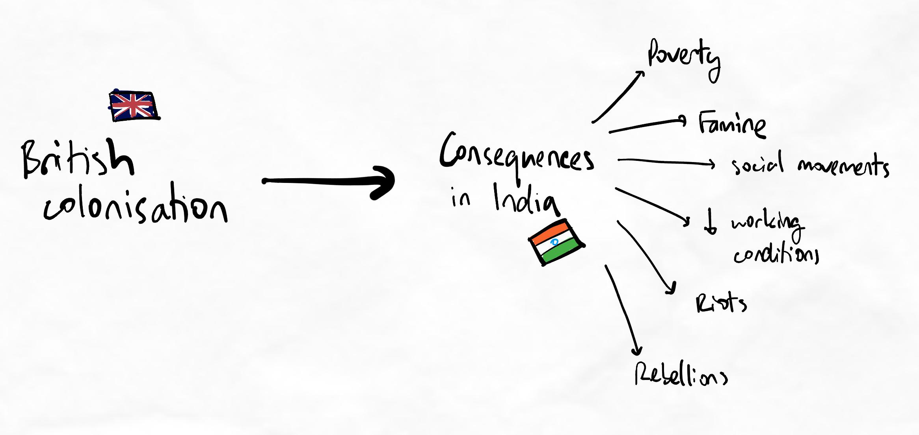In this example, there are six points branching off from the "Consequences in India" chunk.
This can be re-chunked into sub-chunks as follows:
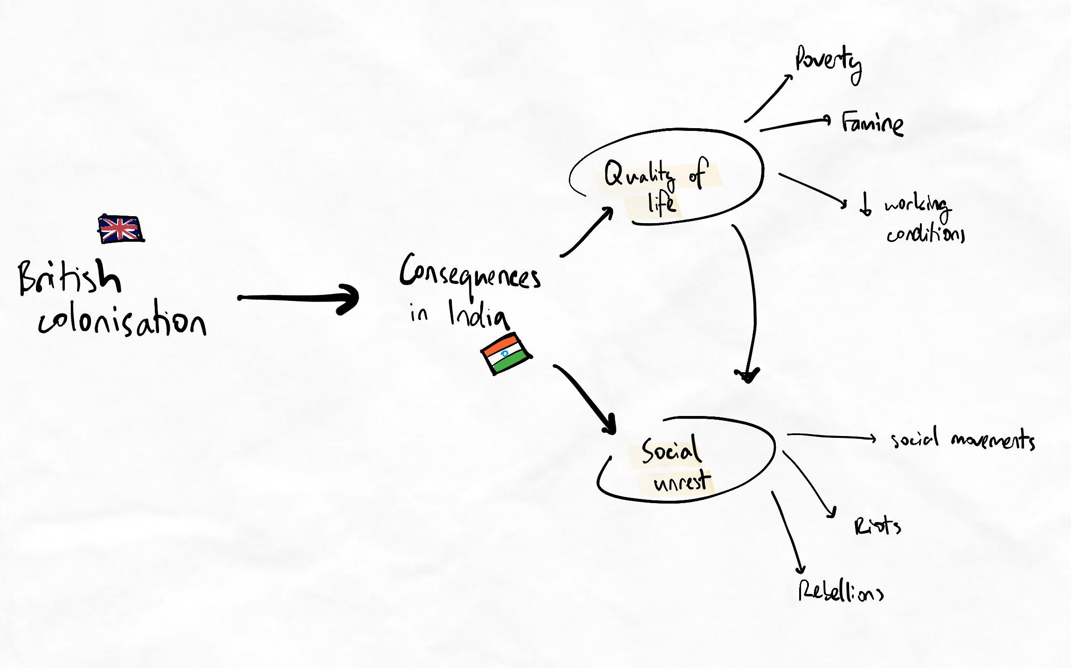There are now two sub-chunks with three points each.
Notice how, by re-chunking, we have also added a new lateral relationship between the sub-chunks that would have previously created spiderwebbing.
Key principles
- When there are more than four points from a single chunk, it should be sub-chunked.
- Sub-chunking can reduce spiderwebbing and allow lateral relationships to be expressed more cleanly.
Example: Less than two
The following example shows a situation where less than two concepts come from a single chunk. In this situation, it clutters the space without adding organisational value. In this situation, we can try to concatenate (i.e. merge).
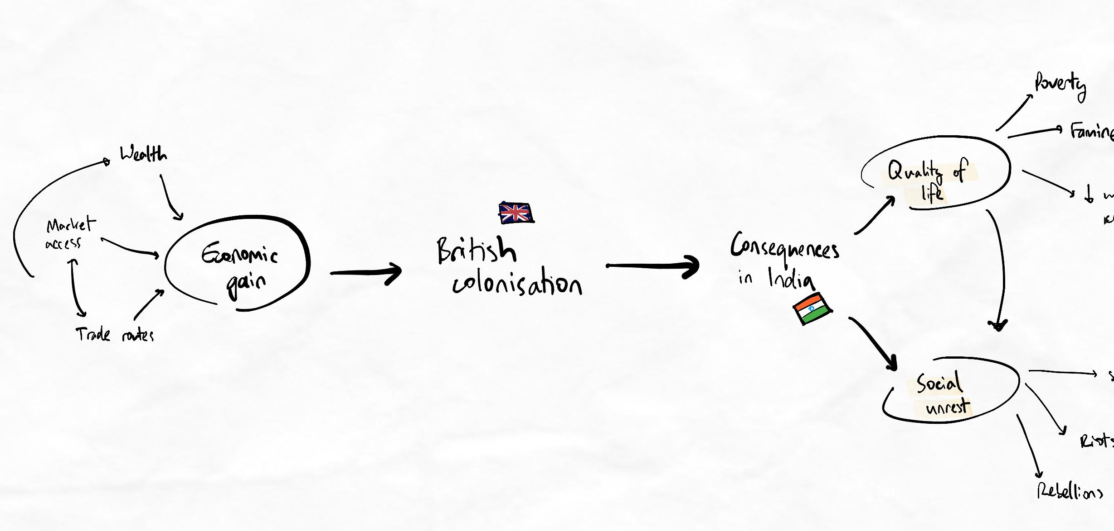Notice that "British colonisation" in the middle only leads to one chunk, "Consequences in India".
When a chunk or concept links only from one chunk or concept to one other chunk or concept, we call this a single-node chain.
Key principles
- Nodes with one in-bound and one out-bound connection are called single-node chains.
- Single-node chains indicate that the chunk structure can usually be optimised as these nodes will have fewer relationships and connections.
- Single-node chains may become weak points that are at risk of lower retention of mastery.
In this situation, we must move British colonisation somewhere.
After considering what makes the most sense, we might altogether remove British colonisation from the flow to create a flow of "Drivers" to "Consequences". This is logical, and since the entire topic is about British colonisation, we are unlikely to forget what the drivers or consequences are referring to. It is obvious enough that the drivers are "drivers for British colonisation", and consequences are "consequences of British colonisation".
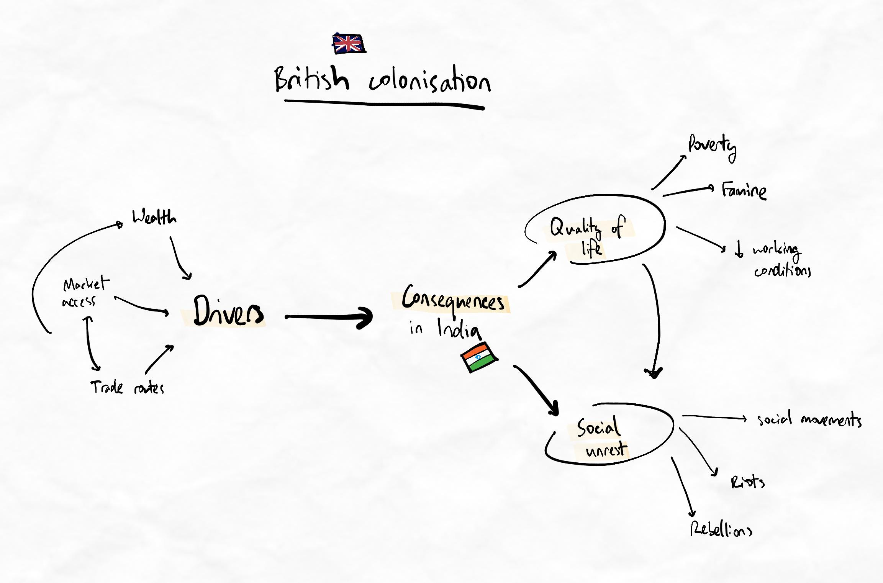There are no longer any single-node chains.
Notice we have re-chunked "economic gain" to become "drivers" so that the relationship to "consequences" is much more straightforward and intuitive. The chunk "economic gain" might be reintroduced later if we find multiple other drivers that could break the 2-4 Rule again (e.g. political or religious drivers).
An example of this scenario is given below to show the reintroduction of "economic gain" as a sub-chunk:
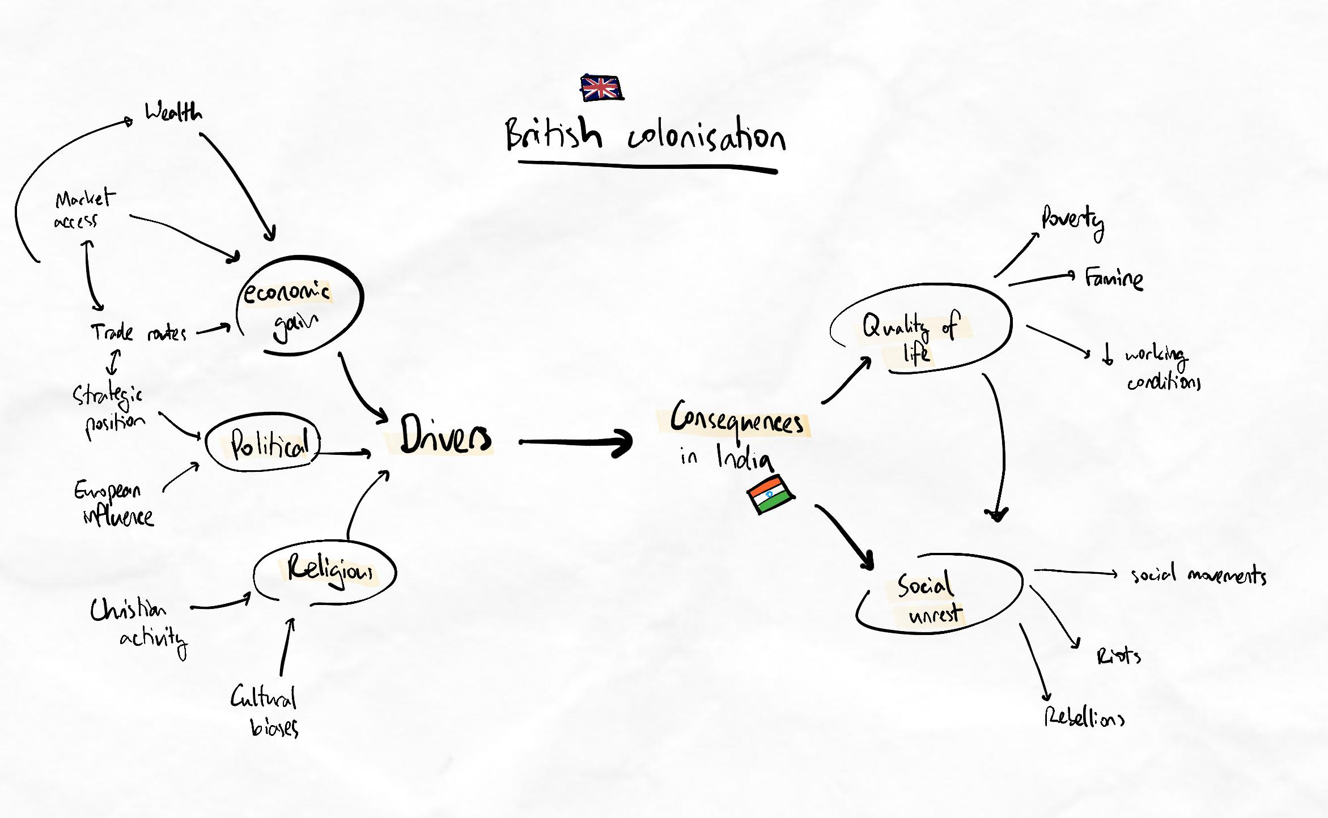Notice the three new sub-chunks under "Drivers". This would break the 2-4 Rule if not sub-chunked.
By continually chunking, sub-chunking, and re-chunking to find the simplest structure possible, we free up cognitive and physical space in our notes to explore additional relationships.
In this way, our understanding can become deeper, more nuanced, and intricately organised. You can see that some important and complex relationships between concepts have been represented above, despite looking organised and simple.
Each decision to chunk, re-chunk, re-arrange on the map, and sub-chunk is a higher-order decision involving the evaluate level of thinking.
Persistence is crucial
Rechunking to abide by the 2-4 Rule can involve substantial cognitive effort and thinking. Remember, your role as a learner is to find the structure that works. Look for the solution and persist until you find it! If we give up because it is difficult, we will sacrifice the quality of our learning. As you continue this, it will become easier and faster.
Example: Less than two (with a terminal node)
Sometimes, we can end up with less than two concepts from a single chunk and no further connections beyond this. As there are no further connections, we could say that the single-node chain leads to a terminal node. Terminal nodes are like the leaves of a tree.
An example of this is given here and boxed in red:
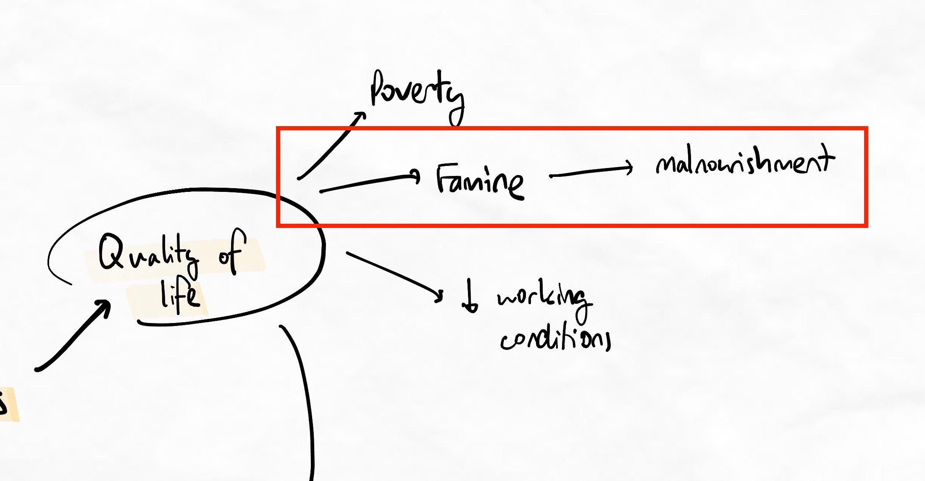"Famine" has one in-bound and one out-bound connection. "Malnourishment" has no further connections, making it a terminal node.
This is also a single-node chain.
Concatenating this can be easily achieved by adding "malnourishment" to "Famine" directly. This creates a clearer and less cluttered map.
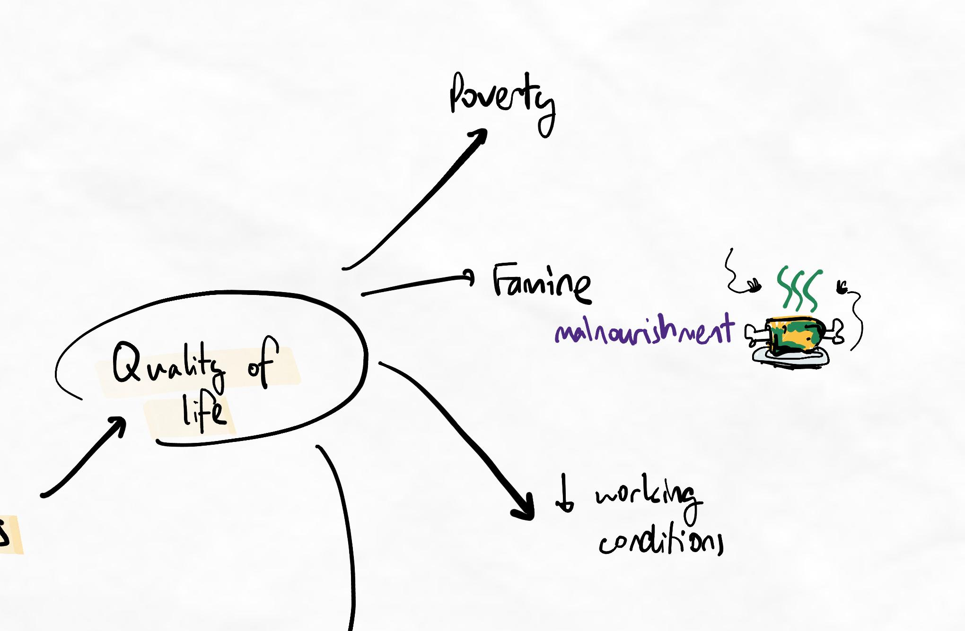Notice that "Poverty" and "working conditions" were moved further away to give more space to "Famine". A visualisation of rotting meat was added as a memory anchor to help remember malnourishment. In this example, we assume that malnourishment is a layer 3 detail and still needs to be in this mindmap.
When you chunk in this way, you are building highly organised groups of concepts.
These concepts will also be represented more simply, as good chunking improves the spatial arrangement of your mind map. With more chunks, you will have fewer isolated points, which means fewer arrows and a less complicated mind map. The beauty of this is that you aren’t sacrificing your connections and relationships because the chunks are still connected!

- GRINDE maps
We're on the GRINDE
GRINDE maps are the final and best version of your mind map. GRINDE is an acronym that we use to refine our mind map during the ‘skin’ step.
You may notice similarities with VPReFRE; this is because GRINDE is a mindmap-specific extension of the same guidelines.
Grouped
This is where we chunk the information on the mind map, as outlined in the previous lesson.
Reflective
Here, you reflect on the order control, just like with VPReFRE. Pay attention to the order of the relationships, logic, concepts, and details to determine whether it reflects the way your brain understands the topic.
Your mind map should fulfil the layers of learning; if it doesn’t, take this opportunity to sort the information into clear layers (backbone/logic → concepts → important details).
Tip
This additional effort to make the layers clear is a characteristic indication of an advanced level learner.
Interconnected
Make sure your arrows are interconnected and not all pointing in a single direction or going purely outwards. There should be connections between chunks and concepts within the same layer as well as between layers (where relevant and important).
Good chunking creates nice, simple branching. Good interconnectedness extends this into a web of concepts that clearly influence each other. There is a clear sense of purpose to the information.
Wheel and spokes
The wheel and spokes problem is when there may be good chunking, but all of the relationships seem to radiate out from a central hub. This indicates a lack of lateral connectivity between chunks and concepts.
Non-verbal
Use doodles, visuals, and as few words as possible. An image will help you retain much more information than lines of words. You should also explore shorthand and contractions that you can use to form your own personal abbreviation system!
Directional
Have a flow of information and ideas in your mind map. This way, your mind map will be more logical because it shows the influence of concepts on other concepts. You always need to relate information to the big picture, as this will give you a sense of direction in your learning.
Whether or not your mind map is directional will heavily depend on how you stick to the Aim step, your problem-solving mentality, and how importance-based your first layer of logic is.
Emphasised
Make sure the layers are easy to see. You can do this by using different sizes, colours, or fonts.
Although this may seem insignificant, it helps you to pick out the main logic layer, concepts and sub-concepts much faster. This speeds up your revision time and facilitates your brain’s ability to create relationships. Cognitively, it improves learning because it requires you to be highly explicit about which concepts and relationships are most important. Think of it like building mental highways and motorways.

Sublesson: GRINDE map examples
GRINDE map examples
GRINDE map – example
In this lesson, we use the GRINDE checklist to improve this example mind map.

- Skin examples
In the sublessons below, we demonstrate the usage of the Skin step across a variety of subjects. Even if your particular discipline is not included as an example, the methods of thinking are completely transferrable.
You can skip sub-lessons you are not interested in by marking them as complete. However, we recommend watching several different examples to get a clear understanding of the technique.
Sublessons:
- Biology 1
- Biology 2
- Chemistry
- English – text response
- English – unfamiliar text
- Languages
- Maths

- Intuitive chunking
Key principles
- Chunks are “intuitive” when they leverage prior knowledge. The more you rely on prior knowledge, the more logical it feels, and the less memorisation is required.
- When you compare chunk structures and decide which one makes the most sense to you, you are engaging in higher-order learning.
- Rather than looking for a single “right answer,” you want to find the answer that best fits your knowledge schema.
- Instead of just deciding on a chunk structure and not evaluating alternatives, look for opportunities to reverse-chunk so your chunking is truly importance-based.
- When performed correctly, importance-based chunking creates intuitive chunks. By checking whether our chunks are intuitive, we can see whether or not we’ve performed importance-based chunking.
Meta-checklist
This table outlines how using this technique can feel and what these feelings mean at a cognitive level. Refer to this to improve your metacognition and ensure you understand the technique’s purpose. Connecting your emotional experience with the cognitive processes of learning helps you make fine-tuned adjustments and solve any technique issues more easily.
How it can feel | Cognitive outcomes
Feeling overwhelmed, similar to when you first learned the Aim step.  This happens because you have to think about the best way to represent and label your chunks. | Forces prioritisation and evaluation at a higher level than previous versions of your technique.  Creates deeper, more memorable structures.
Suddenly feeling slower and less fluent than before. | This feeling is caused by the above. The standard for high-quality chunking and encoding has increased.  As usual, this will become easier with practice.

- Final checkpoint – Ascent 3
Checkpoint tasks
Complete the recommended tasks below before moving on to the competence assessment and checklist below.
Recommended tasks
Add tasks to your focus list so you can practice the skills.
Dimensions
Ascent III
Complete an Ascent III level challenge week
Complete a challenge week by applying all of the methods you have learned so far. Make sure to incorporate:
  - The full BHS (Aim-Shoot-Skin) on different topics
  - Clear and consistent identification and expression of layers of learning
  - Optimal chunking using the 2-4 Rule and intuitive chunking
  - Multi-order interleaved retrieval practice
  - Appropriate time management and prioritisation
  - Appropriate focus and attention management
  - Kolb's at least 3 times during the week with cycling of experiments into subsequent Kolb's cycles
Complete this task once you have completed your challenge week.

Dimensions
Ascent II
Complete a skill audit
Using the checkpoints and meta-checklists so far, complete a skills audit on your current skill level and learning system. Implement any findings as experiments into your next Kolb's cycle.
Complete this task once you have completed your skill audit.

Growth phase progress
Ascent 3 marks the end of the intensive encoding strategies segment of the Growth phase.
In the later stages, we start to develop the usage of these skills more time-efficiently and in more complex combinations and systems. Issues with encoding quality, effectiveness, or consistency are unlikely to be improved by the lessons in future stages.
If you are doubtful of your competence at this point, the greatest improvement will come from practice and feedback rather than later theory.
Rapid skill assessment
If you do not notice the following general improvements from a rapid skill assessment, there is a high chance that your techniques or system requires optimisation.
Expected findings at this stage...
- Significant improvements with retention after first encoding session.
- Significant improvements with retrieval performance across a diverse range of challenges and contexts.
- Reduction in total study time and increase in efficiency due to reduced time spent on relearning.
- Significant improvements in confidence.
- Significant improvements in growth mindset and ability to learn from mistakes and experiments.
- A clear appreciation for the type of thinking that higher-order learning triggers and a high tolerance for cognitive load and discomfort.
If your experience does not align with the above expectations, we strongly recommend seeking feedback on your practice.
General competence assessment
Technique(s) | Level of Competency
Bear Hunter System | You are moderately comfortable with aim-shoot cycling and skin steps.  You have high levels of chunking and very clear, prioritised relationships.  Your GRINDE maps have a good flow and are highly memorable.
Focus, Scheduling and Revision | You are continuing to use these with ease. We will build on these soon in Base Camp.
Unlocking the next stage
Base Camp is unlocked 21 days after Ascent 2 is completed. If you've been practising the new theory and progressing at the recommended pace, it should be unlocked already by now!
If the next stage is still not unlocked, please use this time to practise your current method and gain deeper mastery.

Quiz: Ascent 3 checkpoint quiz

Spot the issues!
In the following quiz, we will show you some work submitted by real students. Each case has a common mistake for you to learn from. Sometimes, you will learn about certain mistakes for the first time from these checkpoint quizzes!
Question 1
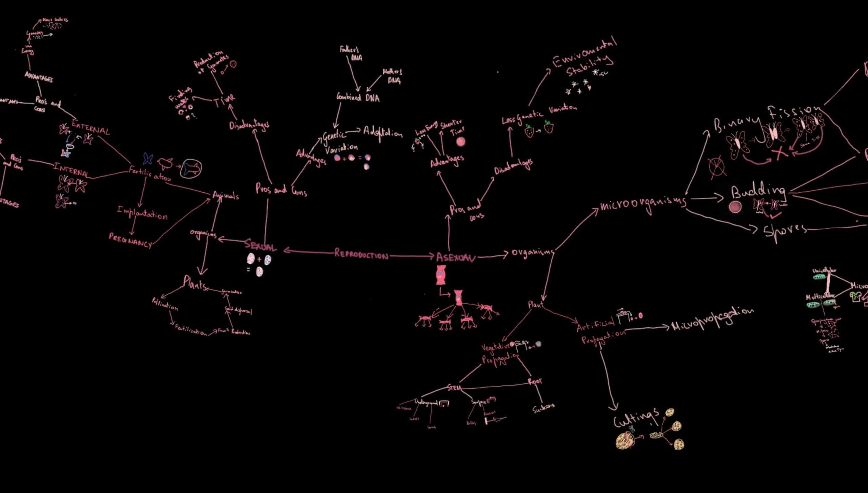
Regarding the work submitted by a student above, answer the questions below.
Which of these patterns are present? Select all that apply.
Intuitive chunking needed
Spiderwebbing
Waterfall
Single node chains
Lonely chunks
Reverse chunking needed
Cracked glass
Ans: Intuitive chunking needed
Single node chains
Reverse chunking needed

Question 2

Regarding the work submitted by a student above, answer the questions below.
Question 2.1
Reverse chunking needed is:
Indicated when the learner has too many chunks.
Indicated when there is repeated information at the ends of chunks branches.
Indicated when there are too few chunks.
Indicated when the chunk structure is not logical or intuitive.
Ans: Indicated when there is repeated information at the ends of chunks branches
Question 2.2
Reverse chunking needed can occur when (choose the most correct option):
Chunking is not importance-based. Instead, the reasons for importance are treated as layer 3 details.
Topics have a high number of repeating similarities across many core concepts.
Topics require a certain format of retrieval, which limits the viable chunk structures that can be formed.
Chunks are logical but not intuitive.
Ans: Chunking is not importance-based. Instead, the reasons for importance are treated as layer 3 details.
Learning notes
Blooming Chunk Structures
Reverse chunking is when we rechunk something based on a repeated element in layer 2 or 3. For example, a specific feature, characteristic, or fact may repeat itself across multiple different chunks in the map. When this happens, we can often explore an alternative chunk structure where this repeated feature, characteristic, or fact becomes the name of the chunk. By doing this, we can rearrange the concepts as sub-chunks or details that come from the new chunk. Many times, this creates a simpler and more intuitive flow of information. The perspective may be unique and more original while maintaining accuracy.
Reverse chunking is not always appropriate. For example, sometimes we end up with repeated elements no matter how we chunk. In this case, we must make a decision about which chunk structure is most appropriate. What’s important is that we evaluate the options instead of assuming one chunk structure is the best before properly exploring alternatives.
Another mistake we see is Single node chains, which are when there is a chunk or “node” of information on the map with only one inbound relationship and one outbound relationship. These nodes are weak points because of the low level of connectivity in the network. Single nodes can often be merged with the node before or after it, re-chunked, or simply removed.

Question 3
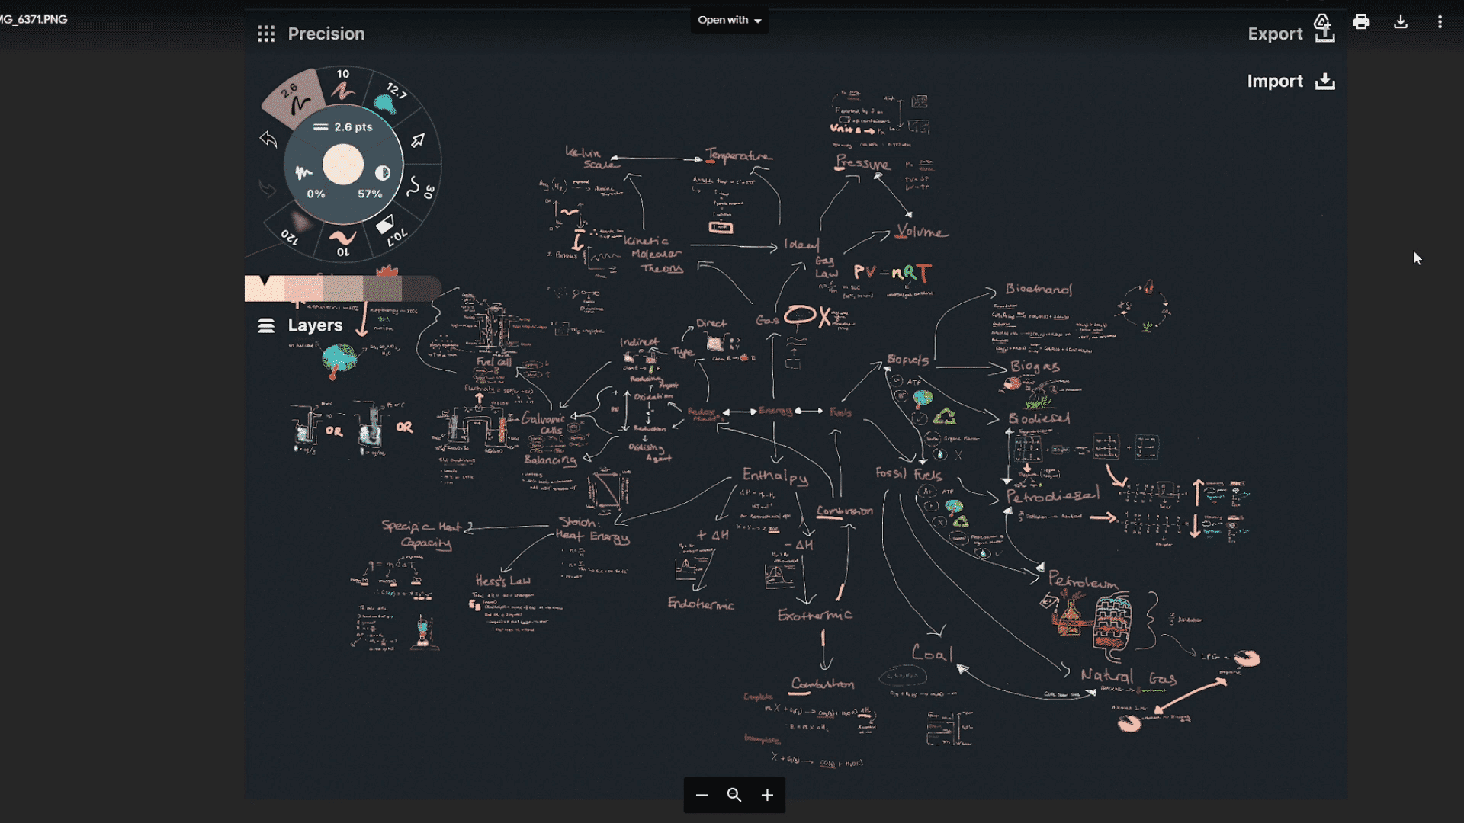
Regarding the work submitted by a student above, answer the questions below.
Which of these patterns are present? Select all that apply.
Waterfalling
Reverse chunking needed
Simple question and answer
Anti-spiderwebbing
Unshaped
No/unclear backbone
Ans: Unshaped
No/unclear backbone

Question 4

Regarding the work submitted by a student above, answer the questions below.
Question 4.1
Unshaped is:
Relationships don't form chunk structures
Grid like chunk structures
Chaotic mindmap that has overlapping relationships
Overall shape of chunk structures are not memorable
Ans: Overall shape of chunk structures are not memorable
Question 4.2
Unshaped occurs because:
Colour coding is missing
Chunk structures are poor
Spatial arrangement is not optimised
Relationships are too superficial
Ans: Spatial arrangement is not optimised
Learning notes
A Collision Of Theories
Unshaped is a common Ascent 2 and 3 mistake that is easily fixed. It refers to a map that lacks a clearly defined shape. The overall “shape” of each topic is unique. This is because the relationships and chunk structures are unique. Unshaped occurs when the spatial arrangement is not emphasised. By being more deliberate and intentional with our spatial arrangement, we force a higher level of evaluation by being more explicit with how we want to express relationships and main flows. It also creates a visually more distinctive map which serves as an additional memory cue.
The type of map in this example is a common and normal iteration after Shooting. However, during Skin, we should try to create a clearer shape that expresses the backbone and main relationships more explicitly.

Question 5
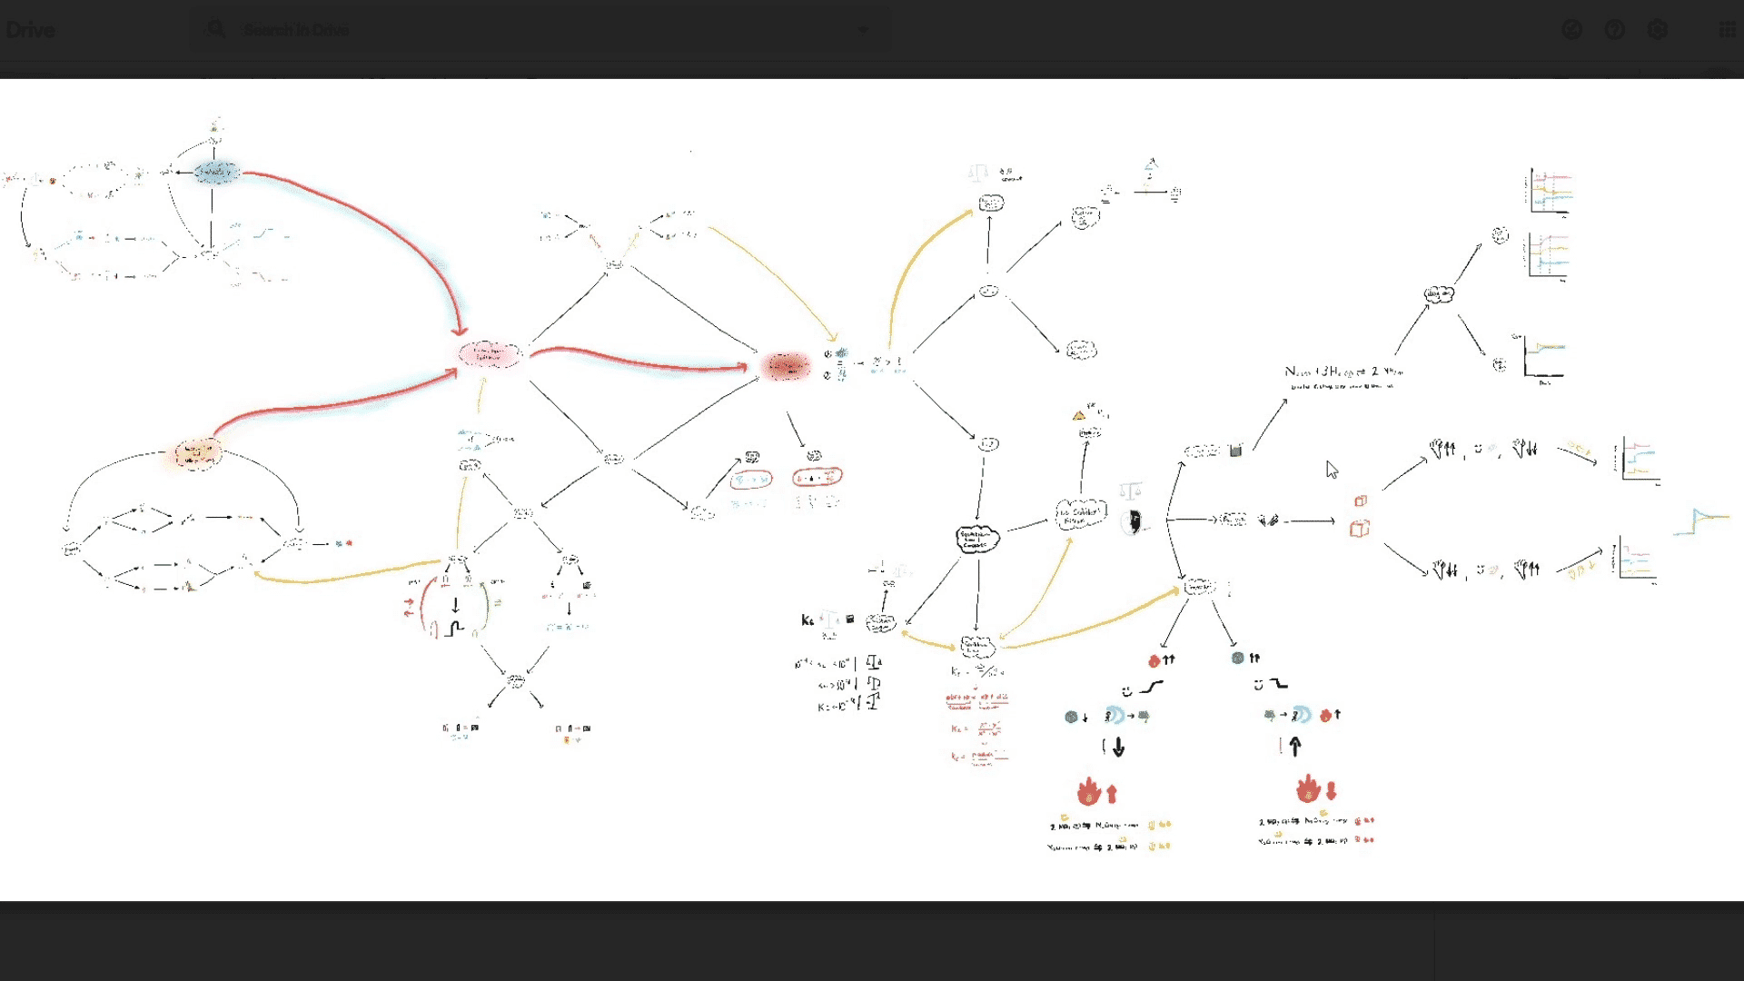
Regarding the work submitted by a student above, answer the questions below.
Which of these patterns are present? Select all that apply.
Reverse chunking needed
No/unclear backbone
Importance checklisting
Islands
Single node chains
Waterfalling
Ans: No/unclear backbone
Single node chains
Learning notes
A Mindmap For Ants

Question 6
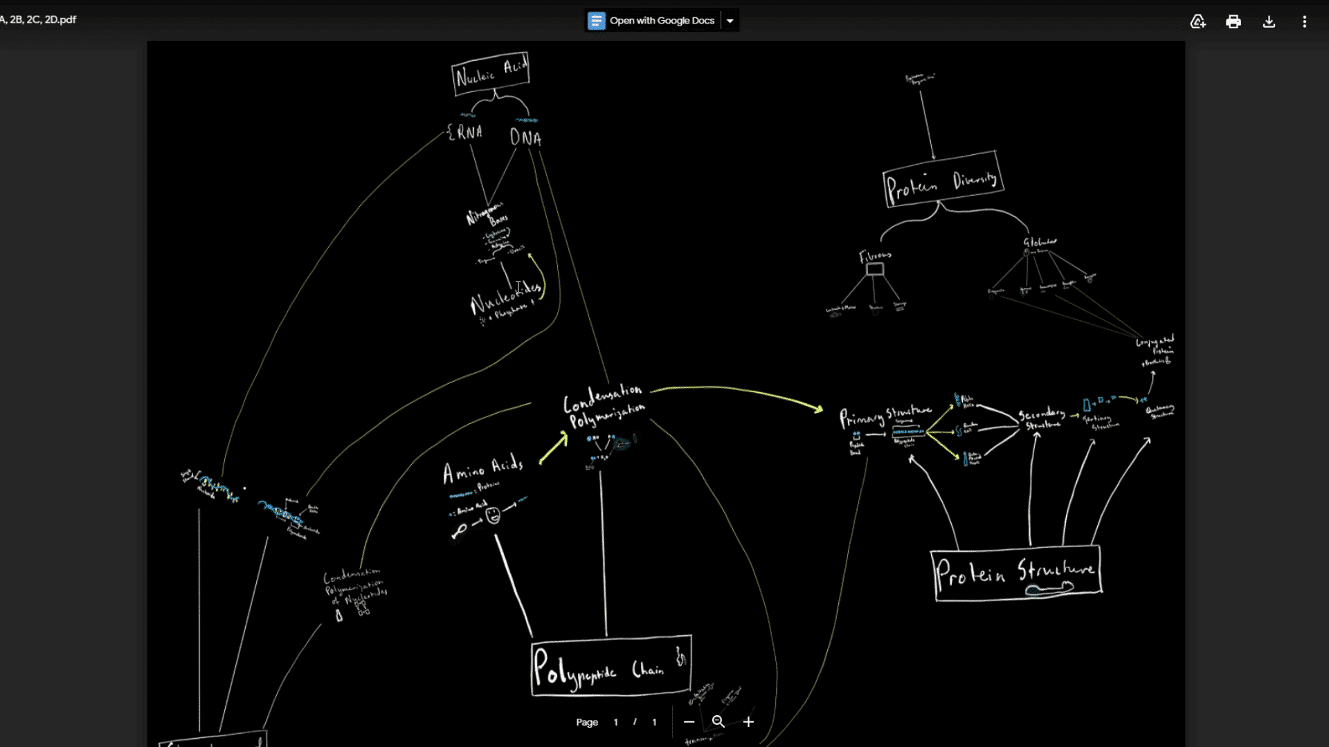
Regarding the work submitted by a student above, answer the questions below.
Which of these patterns are present? Select all that apply.
No backbone
Wheels and spokes
Waterfall
Cracked glass
Islands
Circuit grid
Ans: No backbone
Cracked glass
Islands

Question 7

Regarding the work submitted by a student above, answer the questions below.
Question 7.1
Cracked glass is:
When the mindmap is done in small segments first, then put together at the end, like trying to patch up a cracked glass
Having a backbone with well defined lines, like cracks in a crystal-clear sheet of glass
When the main ideas and chunks of a topic are connected to each other via a web of smaller ideas
Messy relationships and arrows all over the mindmap
Ans: When the main ideas and chunks of a topic are connected to each other via a web of smaller ideas
Question 7.2
Islands is a pattern where chunks in a topic are developed in isolation, the superficially connected to each other. This occurs because:
There was not enough grouping of relationships
Not enough answers were considered when asking “Why is this important?”
There are too many relationships because there were excessive lower-order questions
The main chunks were not clearly related to each other in the early stages of studying
Ans: The main chunks were not clearly related to each other in the early stages of studying
Learning notes
Read Between The Chunks
We see a mild case of Islands and Cracked glass in this example. Cracked glass, as we covered previously, is when chunks are connected via their sub-concepts instead of directly from chunk to chunk. These relationships are often less memorable and superficial. Often, it indicates a lack of clear evaluation between how chunks are related to each other, or the evaluation was done late in the learning process.
Islands are another manifestation of inadequate evaluation of how chunks relate to each other. Islands refers to a larger map that has been created from multiple maps superficially connected together. We often see that there are discrete and relatively isolated patches of dense and more heavily connected networks, and then just a couple of long arrows connecting it to another much denser network. This indicates that each “mini-map” was considered in isolation, without frequent consolidation into the big picture. It can occur if the prestudy was too detailed and narrow or with segmental mapping.
Both Islands and Cracked glass create the illusion of big-picture connectivity. However, the strength and significance of the relationships that connect chunks together are likely to be weak and easily forgettable.

Question 8
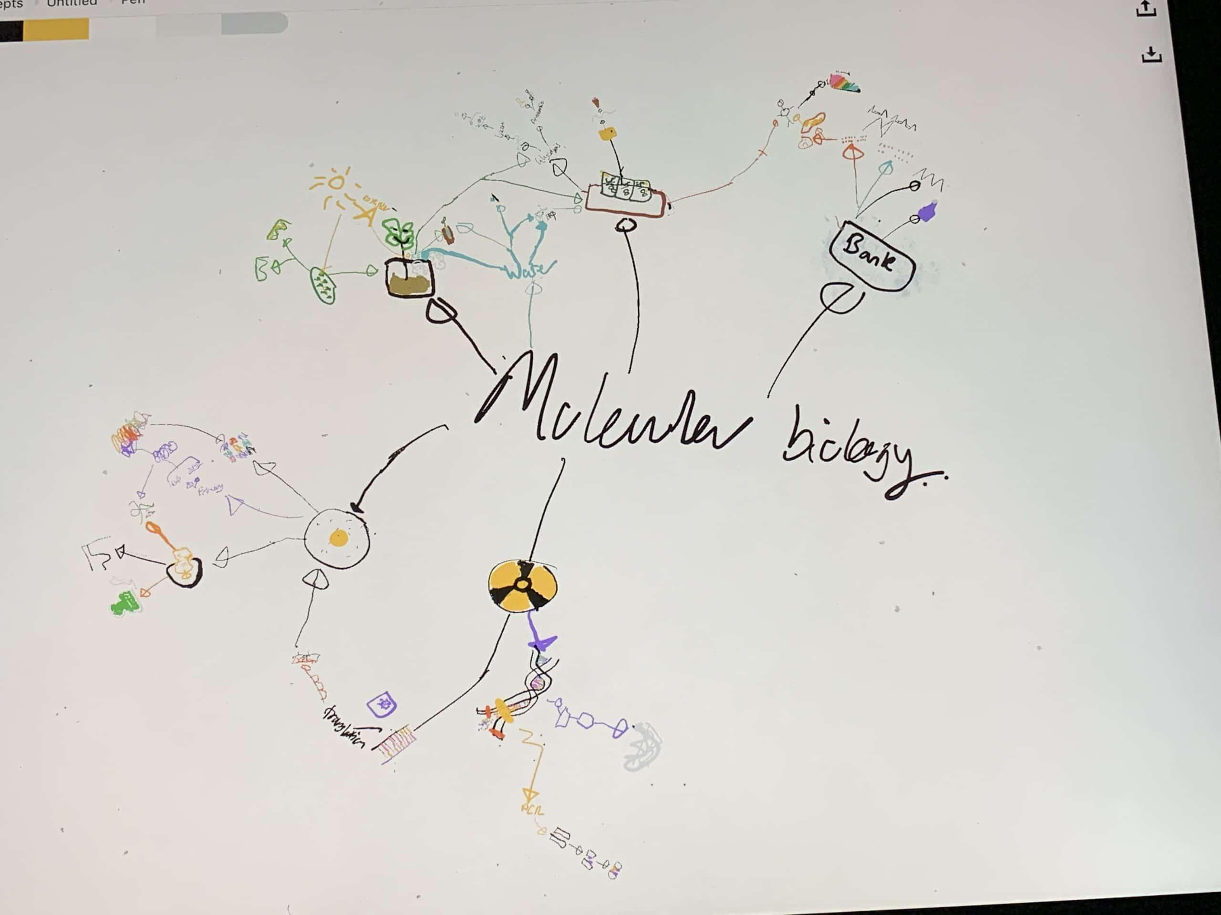
Regarding the work submitted by a student above, answer the questions below.
Which of these patterns are present? Select all that apply.
Insufficient chunking
Too wordy
Cracked glass
Wheel and spokes
Waterfall
Spiderweb
Keyword anchoring needed
Islands
Ans: Insufficient chunking
Wheel and spokes
Keyword anchoring needed

Question 9

Regarding the work submitted by a student above, answer the questions below.
Question 9.1
Wheel and spokes is:
When spiderwebbing creates a dense cycle of relationships that is hard to follow.
When learners have too many chunks and sub-chunks in the topic, creating a wheel-shaped map.
When rotation lock is not enabled for infinite canvas apps, causing a “spinning” mindmap where the shape is not distinctive.
When learners create maps that radiate out from a single, central theme or topic title.
Ans: When learners create maps that radiate out from a single, central theme or topic title.
Question 9.2
Wheel and spokes occurs because:
Rotation lock is not enabled.
Learners are unable to clearly define the different layers of learning.
Learners do not deeply examine similarities between concepts, leading to inaccurate chunks at each layer.
The relationship between the main ideas is not clearly determined and expressed.
Ans: The relationship between the main ideas is not clearly determined and expressed.
Learning notes
Ascent 3 Stopper
Wheel and spokes is when the whole map radiates out from a single, central theme, like spokes on a bicycle wheel. This is often the topic title. In more advanced variations, the learner may repeatedly use a “wheel” or “cycle” pattern of chunk structure for all of their maps. Both of these are indications of inadequate independent chunking. Usually, the name of the topic does not need to be on the map at all.
By placing a central theme, it creates the illusion that everything is connected, by this takes away from exploring the relationship between the key concepts and forming a distinctive backbone. When the main ideas branch from a central theme, it often only represents the idea that “these are the main concepts for this topic”, which should be expressed through a backbone instead. Wheel and spokes sometimes also occurs alongside waterfalling.
Wheel and spokes mistakes tend to create very similar-looking maps for all topics, with a relatively low level of mastery of the core concepts. Learners are not able to retrieve the knowledge in complex and nuanced ways because the core ideas are not deeply connected.
There is also insufficient chunking with five chunks radiating from the central theme. The visuals also need keyword anchors. This is an example of someone who likely rushed the program as these issues should never occur at an Ascent 3 level.

Question 10
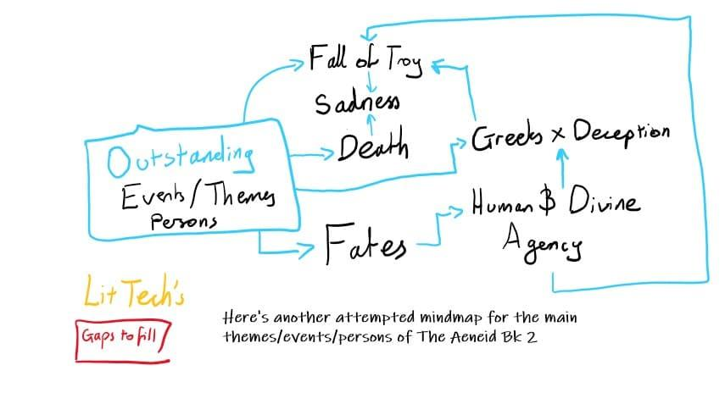
Regarding the work submitted by a student above, answer the questions below.
Which of these patterns are present? Select all that apply.
Unshaped
Detail stripped
Waterfalling
Wheels and spokes
Insufficient chunking
Islands
Ans: Unshaped
Detail stripped

Question 11

Regarding the work submitted by a student above, answer the questions below.
Question 11.1
Detail stripped is:
When mindmaps have offloaded too much detail into layer 4 instead of layer 3.
When mindmaps are lacking the necessary depth and detail in the topic across any layer.
When mindmaps have stripped layer 4 and committed too much information to layer 3.
When the spatial arrangement of a mindmap does not accurately reflect the level of detail within relationships.
Ans: When mindmaps are lacking the necessary depth and detail in the topic across any layer.
Question 11.2
Detail stripped occurs because:
Learners are unclear about the difference between layer 3 and 4.
Learners neglect spatial arrangement of their mindmap and focus on simply adding more relationships to their map.
Learners have lower-order habits that cause them to overcommit to layer 3 or 4 (depending on what they are afraid to forget).
Learners simply do not add more concepts and keywords to the map (either because they are unaware that they should or because they are unsure how to process the extra volume).
Ans: Learners simply do not add more concepts and keywords to the map (either because they are unaware that they should or because they are unsure how to process the extra volume).
Learning notes
Shape Of You
This map is both detail stripped and unshaped. Detail stripped refers to a map where the more detailed layers are not expressed at all. It leads to a very simple and “barren” map. While this may be appropriate for the early phases of learning a new topic or for testing hypothetical chunk structures, leaving maps without sufficient detail is detrimental as it avoids processing the more detailed information that we will need to retrieve. It also makes it harder to see additional relationships between detailed concepts and facts, which may further refine and challenge our chunk structure.
Learners may avoid adding extra detail and keywords because they feel that they may be overwhelmed. This can be avoided by having a clearer backbone and logic layer, as well as more step-by-step chunking for each new “layer” of keywords and detail (i.e. inquiry, identifying similarities, proposing chunks, evaluating which chunks are most intuitive, and hypothesising chunk structures).

